MACH4METAL

metalworking machinery
Transito 21,
6909 DA BABBERICH
Tel. +31 (0)622453620
mach4metal@hotmail.com
www.mach4metal.com
Bank No : 66.52.13.883
IBAN : NL33 INGB 0665 2138 83
BIC : INGBNL2A

VDF BOEHRINGER DUE 500 x 2000 mm
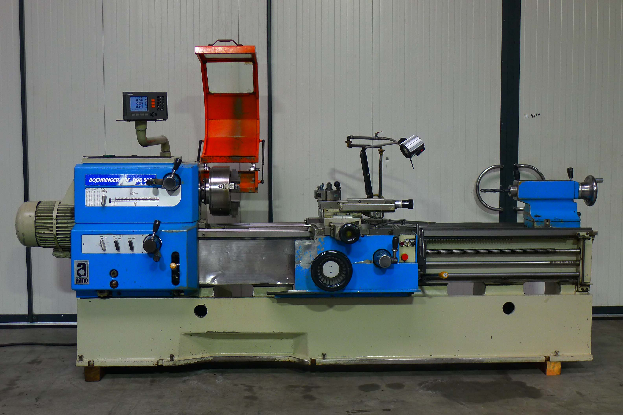

- Make : Boehringer - VDF
- Typ : DUE 500
- Age : 1988
- Mach.No. : 00731 . 01 - 806

- Swing over bed : 520
- Swing over cross slide : 285
- Spindle hole : 62/100

- Gap length : 160
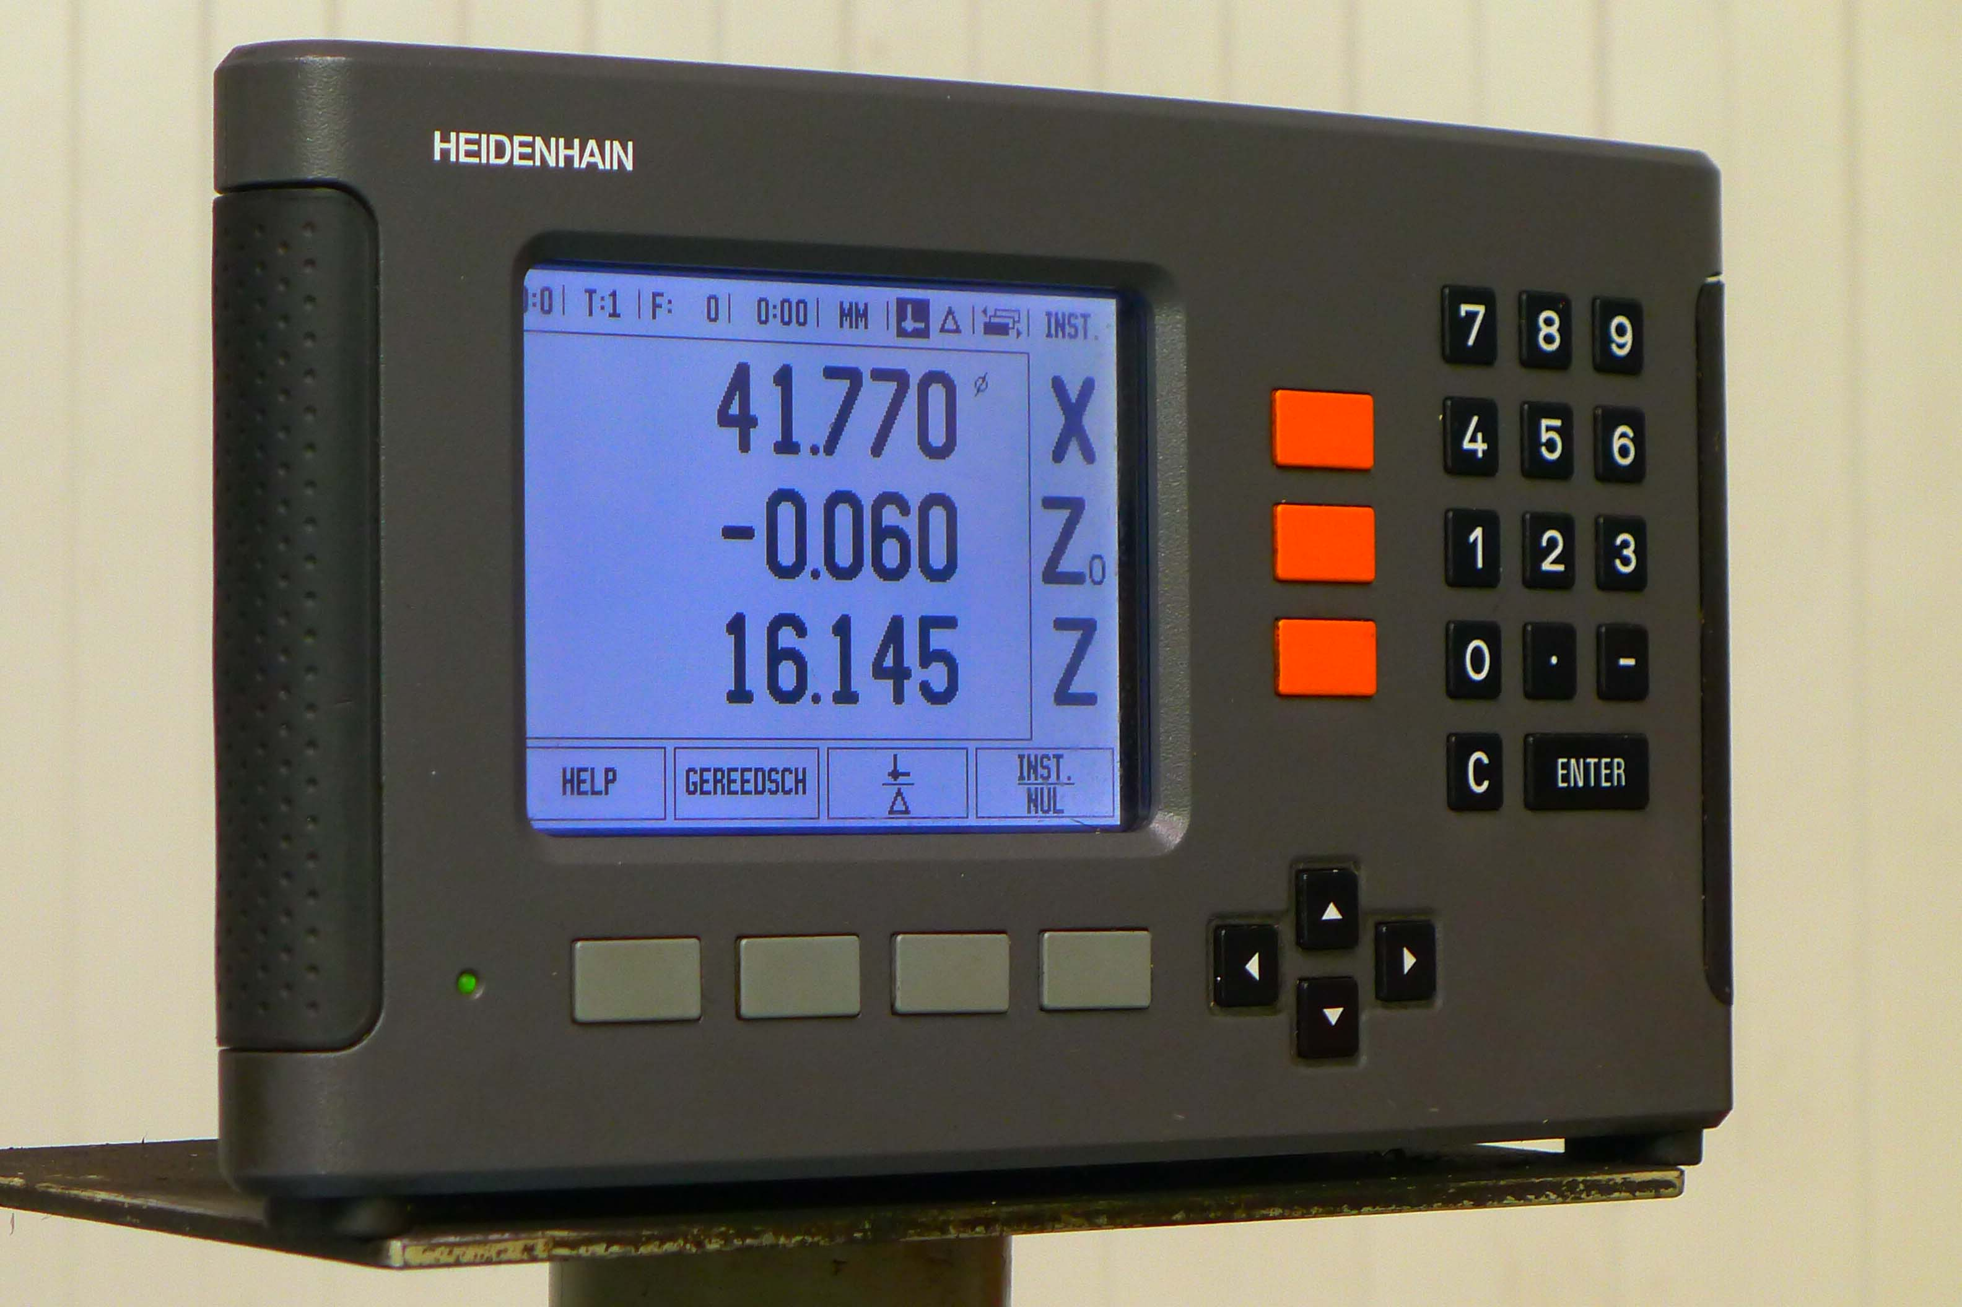
- Turning length : 2.000

- Speeds (24 x) : 11,2 – 2.240
- Feeds : 0,063 – 56

- Dimensions
- Length : 4.210
- Width : 2.000
- Height : 1.650
- Weight : 4.500
- Power : 400 V / 11 kW
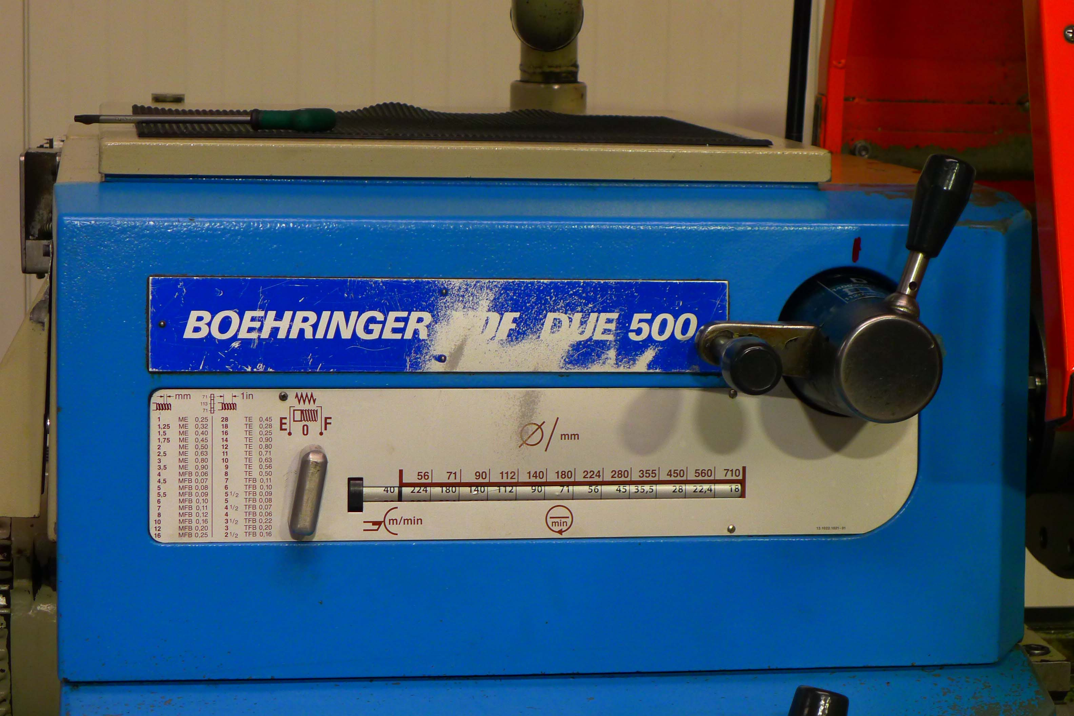

- Incl. HeidenHain ND digital readout
- Incl. Multifix tool system
- Incl. Steady rest
- Incl. 3 chuck Ø 315 incl. many jaws

- Feed in upper support
- Readout in upper support
- Good working condition

Please Note: The above information has been obtained to the best of our ability and belief from, and from the manufacturers where possible. It is given in good faith, but its accuracy can not be guaranteed. Accordingly, it will not form a representation or constitute contractual terms. We advise you to check any vital details

